Lesson 1 of 7 – Evaluating a Learning Algorithm

DECIDING WHAT TO TRY NEXT

- Get more training examples
- Try smaller sets of features
- Try getting additional features
- Try adding polynomial features
- Try decreasing lambda
- Try increasing lambda

Machine learning diagnostic:

Diagnostic: A test that you can run to gain insight what is/isn't working with a learning algorithm, and gain guidance as to how best to improve its performance.

Diagnostics can take time to implement, but doing so can be a very good use of your time.

EVALUATING A HYPOTHESIS

Divide the data set in Training Set and Test Set, in an order of 70% to 30%.

Training/testing procedure for linear regression:
- Learn parameter theta from training data (minimizing training error J of theta);
- Compute test set error;

MODEL SELECTION AND TRAINING/VALIDATION/TEST

Once parameters were fit to some set of data (training set), the error of the parameters as measured on that data (the training error ) Is likely to be lower than the actual generalization error.

Evaluating your hypothesis:

Separate the data set in three sets: training set (60%), cross validation set (CV) (20%), test set (20%).

Use the cross validation error to choose Model selection (the polynomial)

We might generally expect that to be lower than because an extra parameter (d, the degree of the polynomial) has been fit to the cross validation set.
Lesson 2 of 7 – Bias vs. Variance

DIAGNOSING BIAS VS. VARIANCE

Bias/variance

High bias → underfit
High variance → overfit

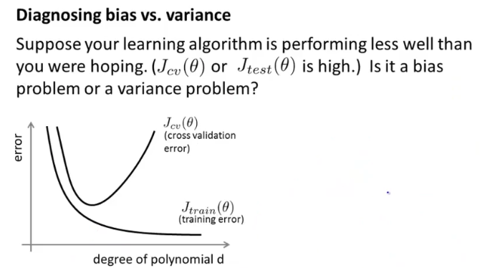
Bias (underfit) → will be high and

Variance (overfit) → will be low

REGULARIZATION AND BIAS/VARIANCE

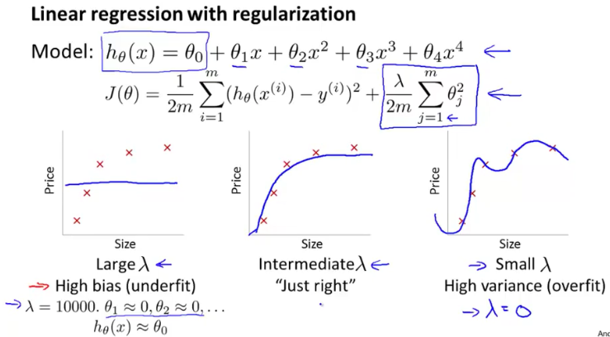
Choosing the regularization parameter

On , and we don't use the regularization term.

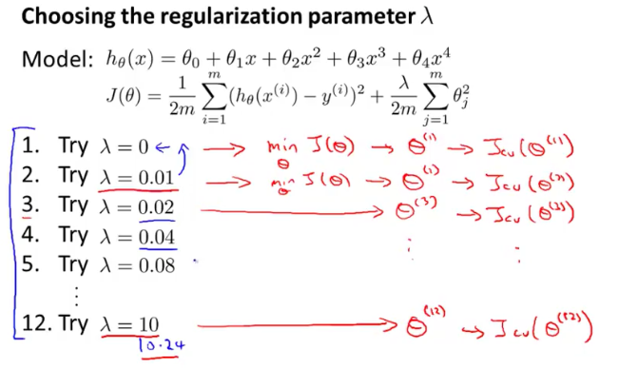
And we choose the lowest to use in the .

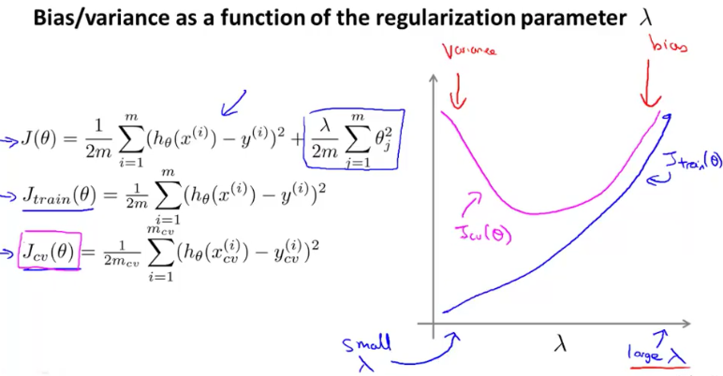
LEARNING CURVES

So in fact as the training set size grows what you find is that my average training error actually increases and so if you plot this figure what you find is that the training set error that is the average error on your hypothesis grows as m grows.

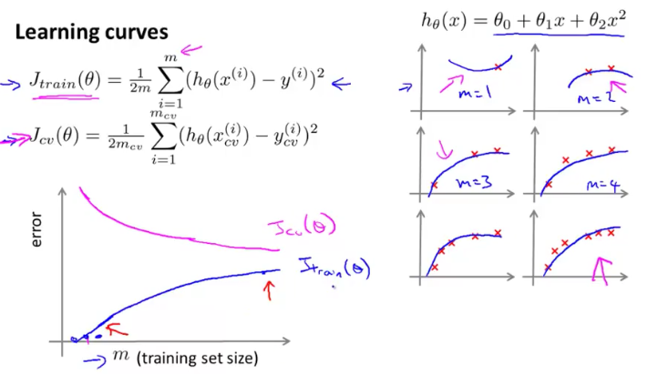

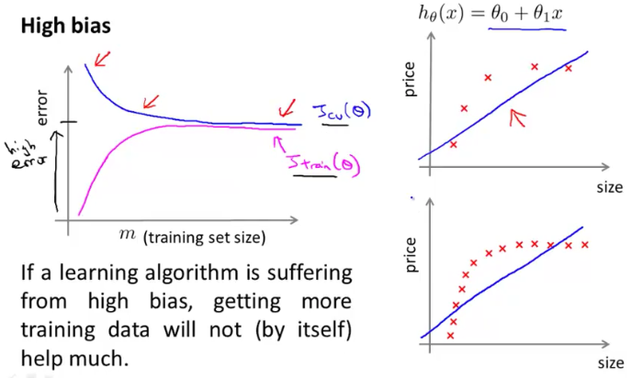
Will end up pretty close to .

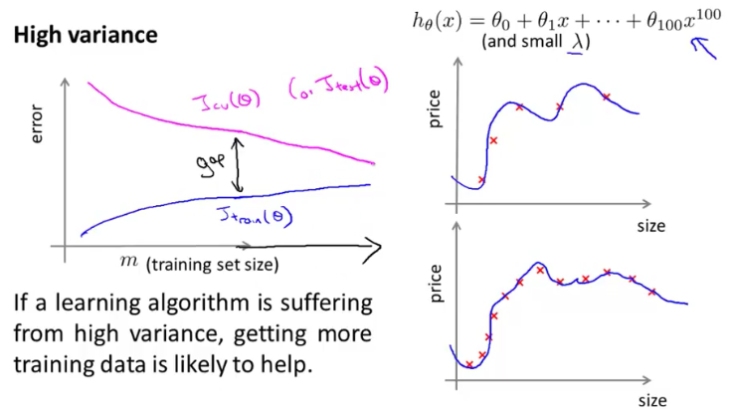
DECIDING WHAT TO DO NEXT – REVISITED

- Get more training examples → fixes high variance
- Try smaller sets of features → fixes high variance
- Try getting additional features → fixes high bias
- Try adding polynomial features → fixes high bias
- Try decreasing lambda → fixes high bias
- Try increasing lambda → fixes high variance

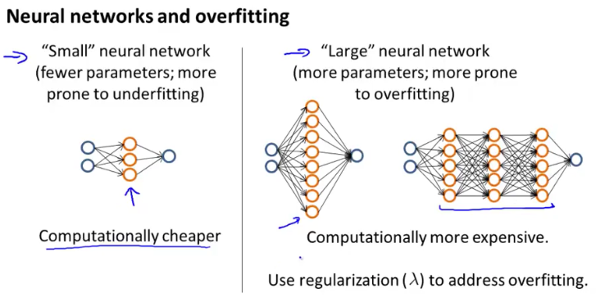
Lesson 4 of 7 – Building a Spam Classifier

PRIORITIZING WHAT TO WORK ON

ERROR ANALYSIS

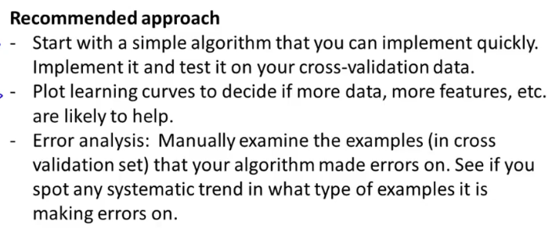
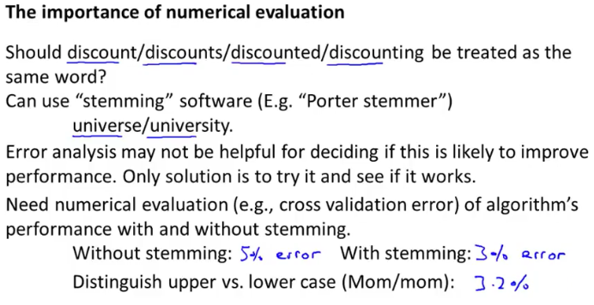
Lesson 4 of 7 – Handling Skewed Data

ERROR METRICS FOR SKEWED CLASSES

Skewed – dados enviesada

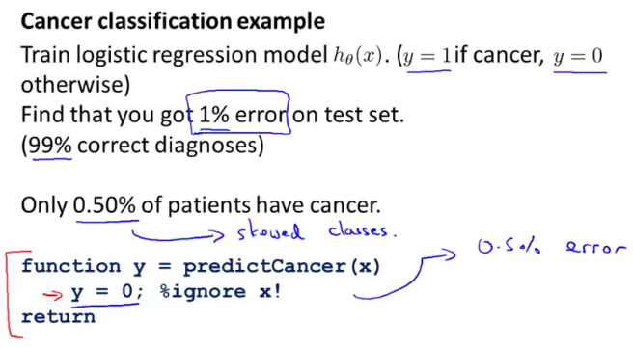
Such situation occurs when one class is over-represented in the data set. A common example for this issue is fraud detection: a very big part of the data set, usually 9x%, describes normal activities and only a small fraction of the data records should get classified as fraud. In such a case, if the model always predicts “normal”, then it is correct 9x% of the time. At first, the accuracy and therewith the quality of such a model might seem surprisingly good, but as soon as you perform some analysis and dig a little bit deeper, it becomes obvious that the model is completely useless.

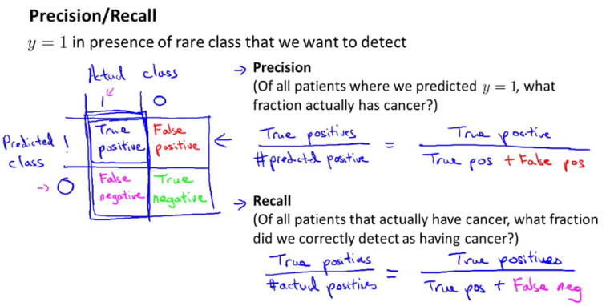
If y is always equal to zero all the time them recall = 0 because there will be any true positives. It its not a good classifier.

And by using precision and recall, we find, what happens is that even if we have very skewed classes, it's not possible for an algorithm to you know, "cheat" and predict y equals 1 all the time, or predict y equals 0 all the time, and get high precision and recall. And in particular, if a classifier is getting high precision and high recall, then we are actually confident that the algorithm has to be doing well, even if we have very skewed classes.

TRADING OFF PRECISION AND RECALL

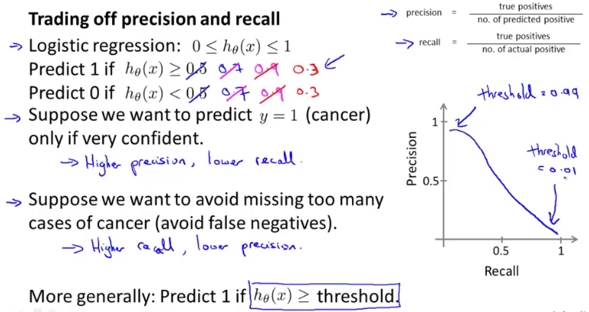
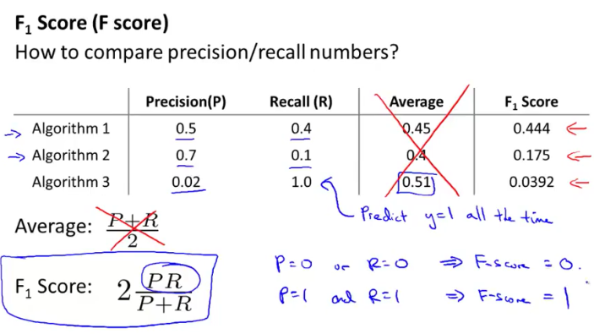
For different values of the threshold parameter, you get different values of precision and recall. Wich of the following would be a reasonable way to pick the value to use for the theshold? → Measure precision and recall on the cross validation set and choose the value of threshold which maximizes the Fscore.

Lesson 6 of 7 – Using Large Data Sets

DATA FOR MACHINE LEARNING

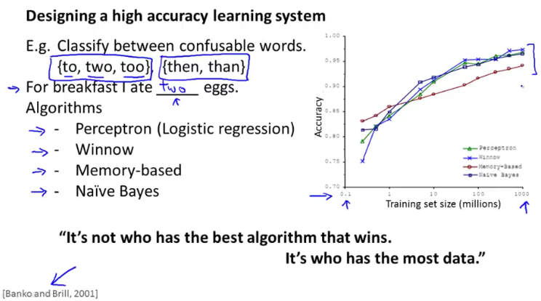
So since this original study which is very influential, there's been a range of many different studies showing similar results that show that many different learning algorithms you know tend to, can sometimes, depending on details, can give pretty similar ranges of performance, but what can really drive performance is you can give the algorithm a ton of training data.

Useful test: Given the input x, can a human expert confidently predict y?
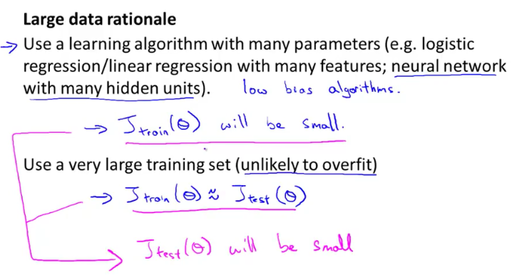
Having a large training set can help significantly improve a learning algorithm's performance. However, the large training set is unlikely to help when:

- The features x do not contain enough information to predict y accurately ( such as predicting a house's price from only its size ), and we are using a simple learning algorithm such as logistic regression. → T

- We are using a learning algorithm with a large number of features (i.e. one with 'low bias'). → F

- The features x do not contain enough information to predict y accurately ( such as predicting a house's price from only its size ), and we are using a neural network with a large number of hidden units. → T

- We are not using regularization. → F

